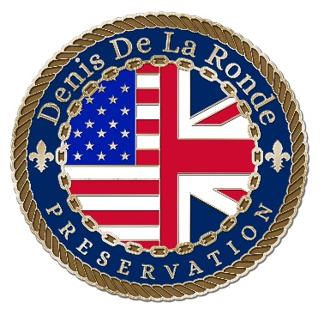
DENIS DE LA RONDE PRESERVATION CORPORATION
MEMBERSHIP APPLICATION

Name: ________________________________________________________________________

Address: ______________________________________________________________________

Email Address: __________________________________________________________________

Telephone Number(s): _____________________________________________________________

Company: ________________________________________________________________________

MEMBERSHIP LEVELS:
___Individual: $50.00
___Couple: $95.00
___Corporate: $250.00
___Additional donation $________
Make check payable to Denis de La Ronde Corporation
Mail to:
Betty Calzada, Treasurer
488 Fairfield Avenue
Gretna, LA 70056

Your generous contribution helps fund site enhancement, preservation projects, and educational programs.
DENIS DE LA RONDE CORPORATION is a 501(c)(3) organization. Contributions are tax deductible as allowed by law.

